MACH4METAL

metalworking machinery
Transito 21,
6909 DA BABBERICH, Netherlands
Tel. + 31 (0)316 – 247123
Fax. + 31 (0)316 - 247956
info@mach4metal.com
www.mach4metal.com

Bank No : 66.52.13.883
IBAN : NL33 INGB 0665 2138 83
BIC : INGBNL2A

KNUTH Bandsaw HB 810 L Ø 810 mm
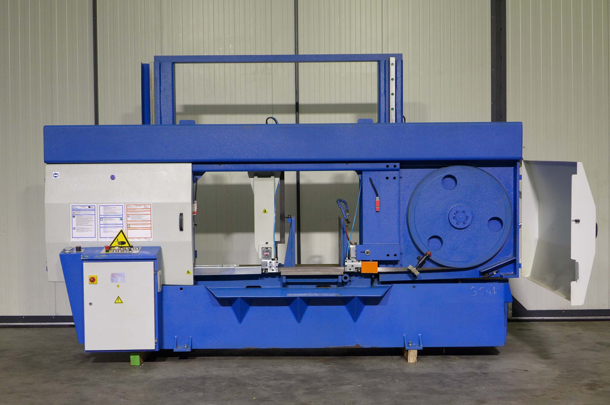

- Make : KNUTH GERMANY
- Typ : HB 810 L
- No :
- Age : 2008

- Cutting 90° Flatt : 810 x 850
- Cutting 90° Round : 810
- Cutting 90° Square : 810

- Cutting 45° Flatt : 480 x 850
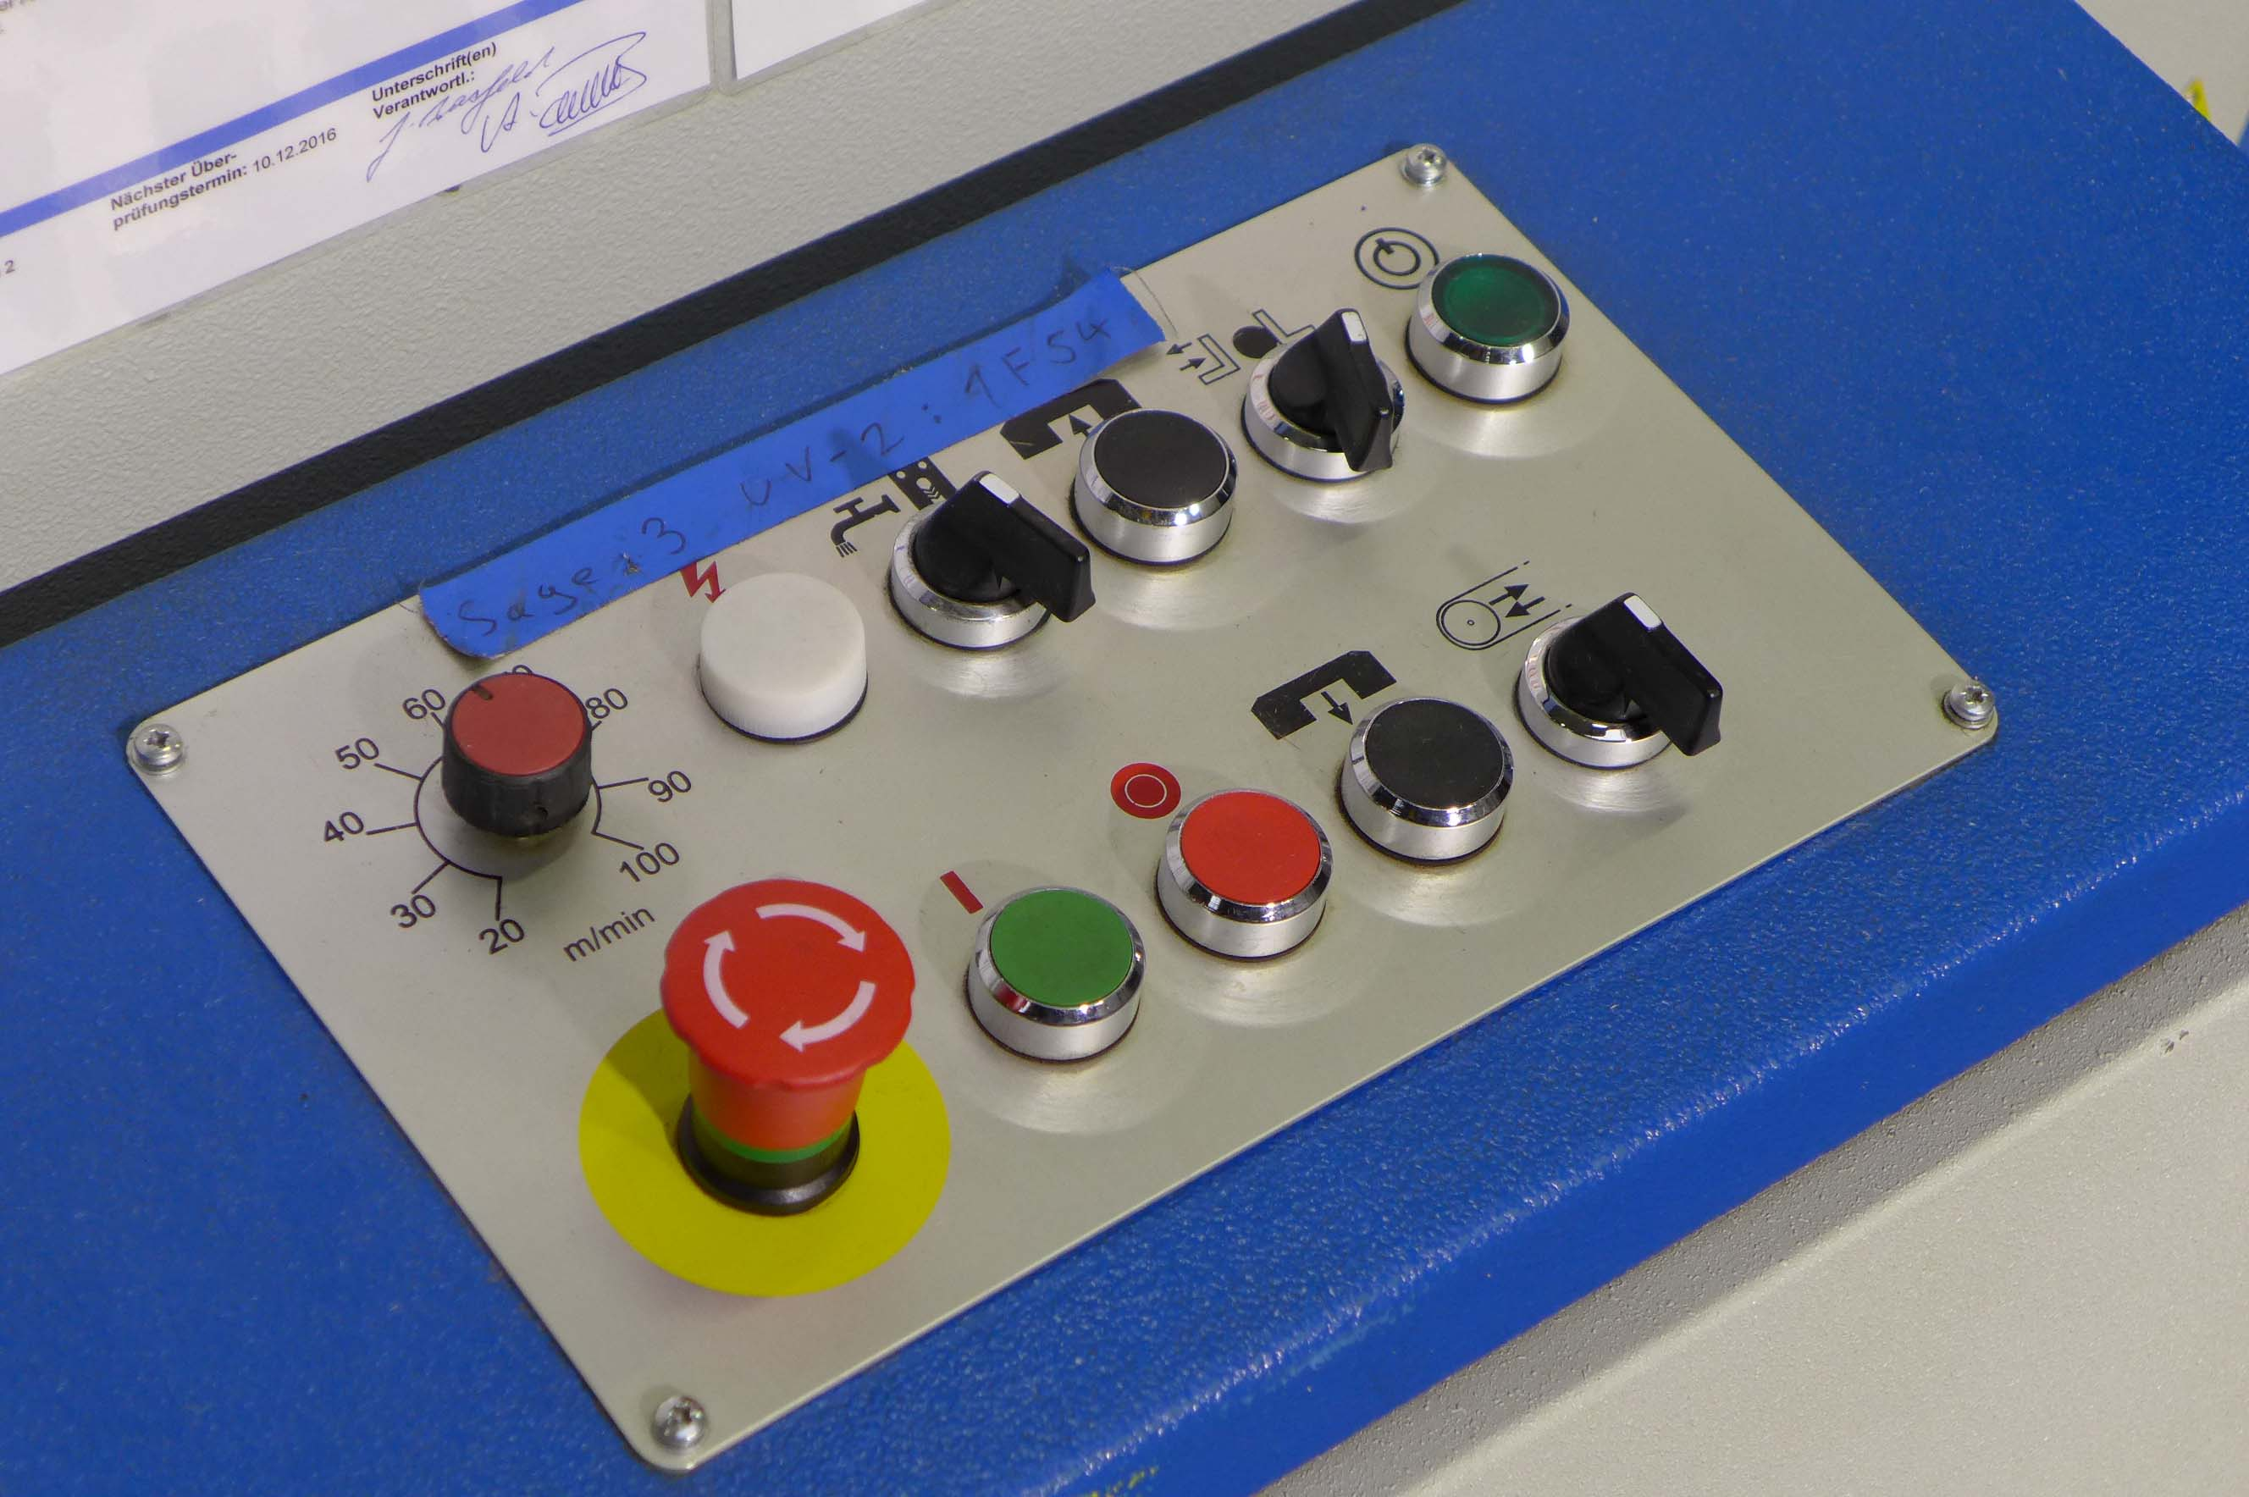
- Cutting 45° Round : 810
- Cutting 45° Square : 810

- Cutting speed : 20 – 100 M/Min
- Power main engine : 4 Kw
- Blade size 8200 x 41 x 1,3 mm

- Dimensions
- Length : 3900
- Width : 1200
- Height : 3350
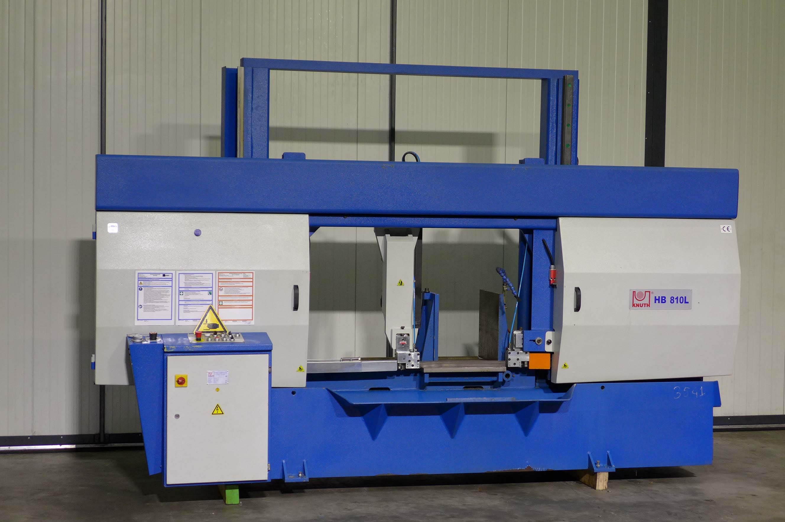
- Weight : 2300

- Very little used
- Inspection possible under power
- Incl. coolant system
- 2 x Roller conveyor 3000 x 600 W x 550

Please Note: The above information has been obtained to the best of our ability and belief from, and from the manufacturers where possible. It is given in good faith, but its accuracy can not be guaranteed. Accordingly, it will not form a representation or constitute contractual terms. We advise you to check any vital details!

